Kitchen Starter Sets You Can Make at Home

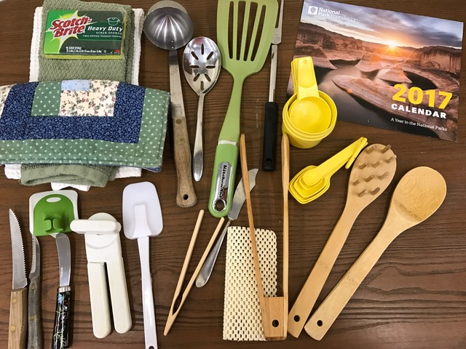
While our clients take great joy selecting items to fill their kitchen drawers, they also treasure our Kitchen Starter Kits, which can help them jump start fulfillment of kitchen and dining essentials. The kits bring the added benefit for our client families and individuals to cook at home rather than frequent fast food options, which is economical and improves nutrition and healthy outcomes. At scale, we can serve as many as 200 homes per-month; and so, these kits are always in need.

Making Kitchen Starter Sets is Easy.
- Collect the essentials listed below and place them in a 2-gallon (jumbo) ziplock bag.
- If Items are new, please remove all packaging in order to fit in the bags. We also gladly accept gently used items.
- Donations are accepted by appointment only. Please contact us in advance to let us know of your effort and to schedule a time to drop off your Kitchen Starter Sets.

Contact Us. We’ll help you get started:
- Email: volunteer@hometomorrow.org
- Telephone: 603.626.3944 Option-4

